**B.TECH. (2020-24)**

**Artificial Intelligence**

**open ended problem**

on

**Database Management Systems**

**[CSE201]**

Submitted To

**Dr Gaurav Dubey**

Submitted By

**Hitesh**

**A023119820027**

**4CSE11 (AI)**

DEPARTMENT OF COMPUTER SCIENCE AND ENGINEERING

AMITY SCHOOL OF ENGINEERING AND TECHNOLOGY

AMITY UNIVERSITY UTTAR PRADESH

NOIDA (U.P)

Open Ended Problem

CASE STUDY - 1

Q.1. A database is being constructed for storing sales information system. A product can be described with a unique product number, product name, selling price, manufacturer name. The product can sale to a particular client and each client have its own unique client number, client name, client addresses, city, pin code, state and total balance to be required to paid. Each client order to buy product from the salesman. In the order, it has unique sales order number, sales order date, client number, salesman number (unique), billed whole payment by the party or not and its delivery date. The salesman has the name, addresses, city, pin code, state, salary of the salesman, delivery date, total quantity ordered, product rate.

ER Diagram

* Assumptions taken for construction of ER Diagram

1. There can be some product which is not sold so there is partial participation from the side of entity ‘Product’ to entity ‘Client’.
2. Some clients may not order any product but are still in client list as they may be regular (or potential) clients who may order later so partial participation.
3. An order can only exist if it has been placed by a client to a salesman, thus total participate from the entity ‘Order’.
4. Some salesmen may not get any order to manage, so Partial Participation.
5. Each salesman would have product details for at least one product thus all salesmen would participate, and each product would have its details with some salesman because only then can they be sold, thus indicating total participation from both sides of the relation (has product details).
6. One product can be sale to many clients and one client can also buy many products thus the relation would have many-to-many cardinality.
7. A client may place more than one order while an order can only be placed by one client thus it would hold one-to-many cardinality from client to order.
8. A salesman may manage many orders, but one order can not be managed by more than one salesman which indicates one-to-many cardinality from salesman to order.
9. One salesman can have product details for one or more products and at the same time one single product can have its details with many salesmen. Thus, the relation between Product and Salesman would have many-to-many cardinality.

Relational Mapping

Database Implementation in SQL

DDL Command Script to create Tables and Insert data to it

|  |
| --- |
| CREATE TABLE products  (  pname varchar(20),  pno number(10) PRIMARY KEY,  sp real,  mname varchar(20)  );  CREATE TABLE clients  (  cno number(10) PRIMARY KEY,  cname varchar(20),  total_balance real,  cstate varchar(20),  city varchar(20),  pincode number(10)  );  CREATE TABLE salesman  (  sno number(10) PRIMARY KEY,  sname varchar(20),  city varchar(20),  sstate varchar(20),  pincode number(10),  totalqty real  );  CREATE TABLE orders  (  orderno number(10) PRIMARY KEY,  sodate date,  deldate date,  billedpay real,  cno number(10),  sno number(10),    CHECK (deldate > sodate),  FOREIGN KEY (cno) REFERENCES clients(cno),  FOREIGN KEY (sno) REFERENCES salesman(sno)  );  CREATE TABLE saleto  (  pno number(10),  cno number(10),  FOREIGN KEY (pno) REFERENCES products (pno),  FOREIGN KEY (cno) REFERENCES clients (cno),  PRIMARY KEY (pno,cno)  );  CREATE TABLE productdetails  (  pno number(10),  sno number(10),  productrate real,  FOREIGN KEY (pno) REFERENCES products (pno),  FOREIGN KEY (sno) REFERENCES salesman (sno),  PRIMARY KEY (pno,sno)  );  INSERT INTO products VALUES('slipper',100,500,'paragon');  INSERT INTO products VALUES('Laptop',102,200000,'hp');  INSERT INTO products VALUES('Television',103,3000,'vermillion');  INSERT INTO clients VALUES(200,'jason',50,'kalos','lumious',110011);  INSERT INTO clients VALUES(201,'raph',500,'hoenn','mauville',120022);  INSERT INTO clients values(203,'nathon',60,'alola','hauoli',120011);  INSERT INTO salesman VALUES(300,'merchantA','coal','bituminous',130012,500);  INSERT INTO salesman VALUES(301,'merchantb','capricon','valley',140029,400);  INSERT INTO orders VALUES(401,'04/02/2022','04/20/2022',2000,203,300);  INSERT INTO orders VALUES(400,'04/01/2022','04/28/2022',2000,200,300);  INSERT INTO orders VALUES(402,'04/05/2022','05/02/2022',100,201,301);  INSERT INTO saleto VALUES(100,203);  INSERT INTO saleto VALUES(103,200);  INSERT INTO saleto VALUES(103,201);  INSERT INTO productdetails VALUES(100,300,3000);  INSERT INTO productdetails VALUES(102,300,3420);  INSERT INTO productdetails VALUES(103,301,3400);  INSERT INTO productdetails VALUES(103,300,400);  INSERT INTO productdetails VALUES(102,301,7777); |

DML Commands

Viewing the Created Tables

|  |
| --- |
| select * from products |

|  |
| --- |
| select * from clients |

|  |
| --- |
| select * from saleto |

|  |
| --- |
| select * from salesman |

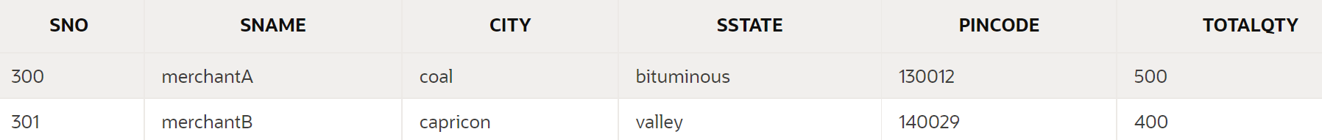

|  |
| --- |
| select * from orders |

|  |
| --- |
| select * from productdetails |

SQL Queries for Validation

1) Display the names of clients who have an ‘p’ as third letter in their name.

Output

2) Display the salesman names and delivery date for those salesmen who got orders with delivery date for month of May.

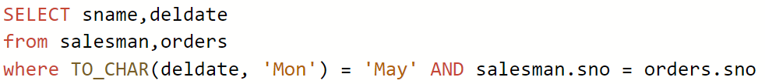

Output



3) Display the name of all salesmen along with the product details of the products which they can sell to clients.



Output

4) Show the details for the Orders placed with client name, salesman, product name.



Output

5) Display the names of clients who bought ‘Television’ in the format “jason buys Television from merchantA with down payment $ 2000”



Output

Open Ended Problem

CASE STUDY - 2

Q.2. A bank database keeps record of the details of customers, accounts, loans and transactions such as deposits or withdraws. Customer record should include customer id, customer name, address, age, contact number, email id etc., accounts details involve account number, account type (fixed account, savings account, monthly account etc), date of creation of the account. Transaction detail keeps information about amount deposited or withdrawn to/from a particular account and the date of transaction. The database should also store record of loans which include loan amount, loan date and the account number to which the loan is granted.

ER Diagram

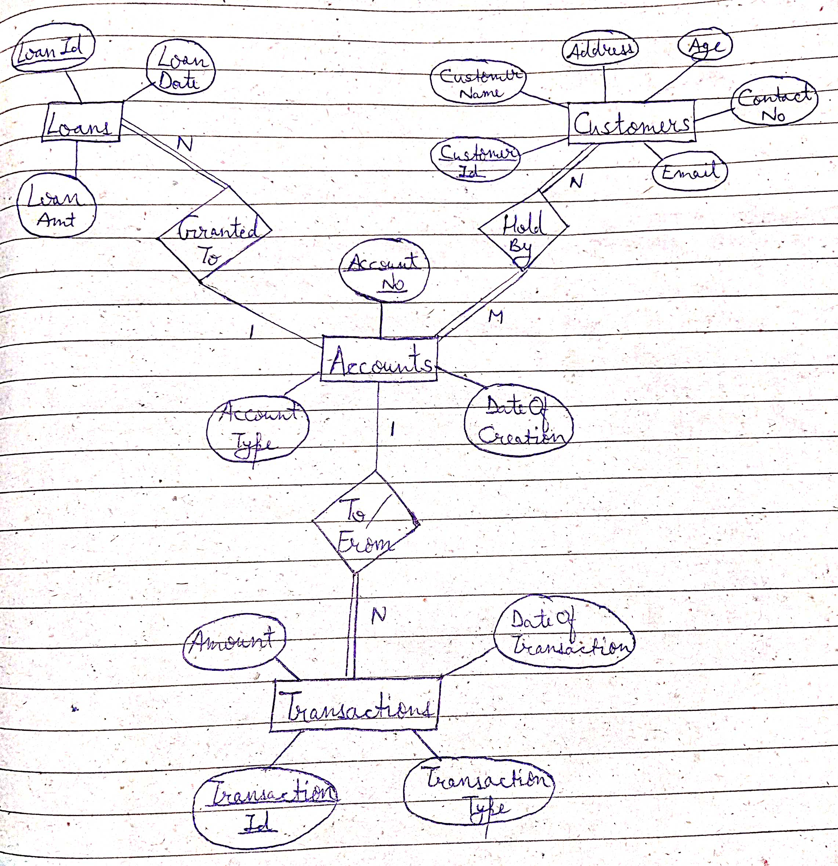

* Assumptions taken for construction of ER Diagram

1. The entity “Loans” has a unique attribute ‘LoanId’ which is the Primary key attribute for the ER diagram.
2. The entity “Transactions” is assumed to have unique attribute ‘TransactionId’ as Primary Key for the ER diagram.
3. For the relation “Granted to”:
   1. An account holder may have multiple loans granted to him/her but each loan will have only one borrower which designates the cardinality one to many where 1 is at Accounts side and N at Loans.
   2. There will be no loan which is recorded but not have granted to an account but there can be accounts without any loans, thus, there will be total participation from entity ‘Loans’ but partial participation from entity ‘Accounts’.
4. For the relation “Hold by”:
   1. There will be many-to-many cardinality assigned to this relation because there can be more than one customer holding a single account in case of a Joint Account, as well as it is possible that one customer may have more than 1 account.
   2. All accounts will have some user assigned to it since otherwise the account can’t exist, meanwhile, each and every customer will be holding at least one account to be considered a customer. Thus, this shows that there is total participation at both ends of the relationship to the entities.
5. For relationship “To/From”:
   1. Cardinality is one-to-many with one ‘Accounts’ side while many at ‘Transactions’ side because a single transaction will either be of depositing to one account (or withdrawing from one account) but there is possibility that multiple transactions can be made for a single account.
   2. Participation is total on ‘Transactions’ side since there can be no transactions which is not mapped with an account for success of deposition or withdrawal.
   3. On the side of entity ‘Accounts’, there is partial participation because there can an account without any transactions being made *considering that depositing of security and minimum balance at the time of account creation is not considered as a transaction.*

Relational Mapping

Database Implementation in SQL

DDL Command Script to create Tables and Insert data to them

|  |
| --- |
| CREATE TABLE Customers  (  CustomerId int,  CustomerName varchar(20),  Addresss varchar(25),  Age int,  ContactNo number(10),  Email varchar(20),  PRIMARY KEY (CustomerId)  );  CREATE TABLE Accounts  (  AccountNo int,  AccountType varchar(10),  DateOfCreation date,    PRIMARY KEY (AccountNo)  );  CREATE TABLE Hold_By  (  AccountNo int,  CustomerId int,  PRIMARY KEY (AccountNo, CustomerId),  FOREIGN KEY (AccountNo) REFERENCES Accounts(AccountNo),  FOREIGN KEY (CustomerId) REFERENCES Customers(CustomerId)  );  CREATE TABLE Transactions  (  TransactionNo int,  TransactionType varchar(10),  Amount float,  DateOfTransaction date,  AccountNo int,  PRIMARY KEY (TransactionNo),  FOREIGN KEY (AccountNo) REFERENCES Accounts(AccountNo)  );  CREATE TABLE Loans  (  LoanId int,  LoanAmt float,  LoanDate date,  AccountNo int,  PRIMARY KEY (LoanId),  FOREIGN KEY (AccountNo) REFERENCES Accounts(AccountNo)  );  INSERT INTO customers VALUES(100,'Raymond','New Jersey',34,1234223232,'raym@tmail.com')  INSERT INTO customers VALUES(101,'Tom','Chicago',25,3342212354,'tom@rmail.com')  INSERT INTO customers VALUES(102,'Benjamin','Michigan',34,9796353234,'ben@tmail.com')  INSERT INTO accounts VALUES(200444,'Fixed','02/22/2022')  INSERT INTO accounts VALUES(200555,'Savings','03/10/2022')  INSERT INTO accounts VALUES(200999,'Monthly','04/01/2022')  INSERT INTO hold_By VALUES(200444,100)  INSERT INTO hold_By VALUES(200555,101)  INSERT INTO hold_By VALUES(200999,102)  INSERT INTO transactions VALUES(300010,'Deposit',9000,'02/23/2022',200444)  INSERT INTO transactions VALUES(301010,'Deposit',4000,'03/25/2022',200555)  INSERT INTO transactions VALUES(302020,'Withdrawal',200,'04/05/2022',200999)  INSERT INTO loans VALUES(444100,35000,'04/02/2022',200555) |

DML Commands

Viewing the Created Tables

|  |
| --- |
| SELECT * FROM customers; |

|  |
| --- |
| SELECT * FROM accounts; |

|  |
| --- |
| SELECT * FROM hold_by; |

|  |
| --- |
| SELECT * FROM transactions; |

|  |
| --- |
| SELECT * FROM loans; |



SQL Queries for Validation

1) Display the customer ID, customer names and their contact numbers who have ‘Savings’ Account.



Output



2) Display the maximum amount transacted (for both deposited and withdrawal).

Output

3) Show the accountNo and account creation date for the accounts granted with a loan amount of 20000 or more.

(Date of Creation should be in format – ‘10th of March 2022’)



Output

